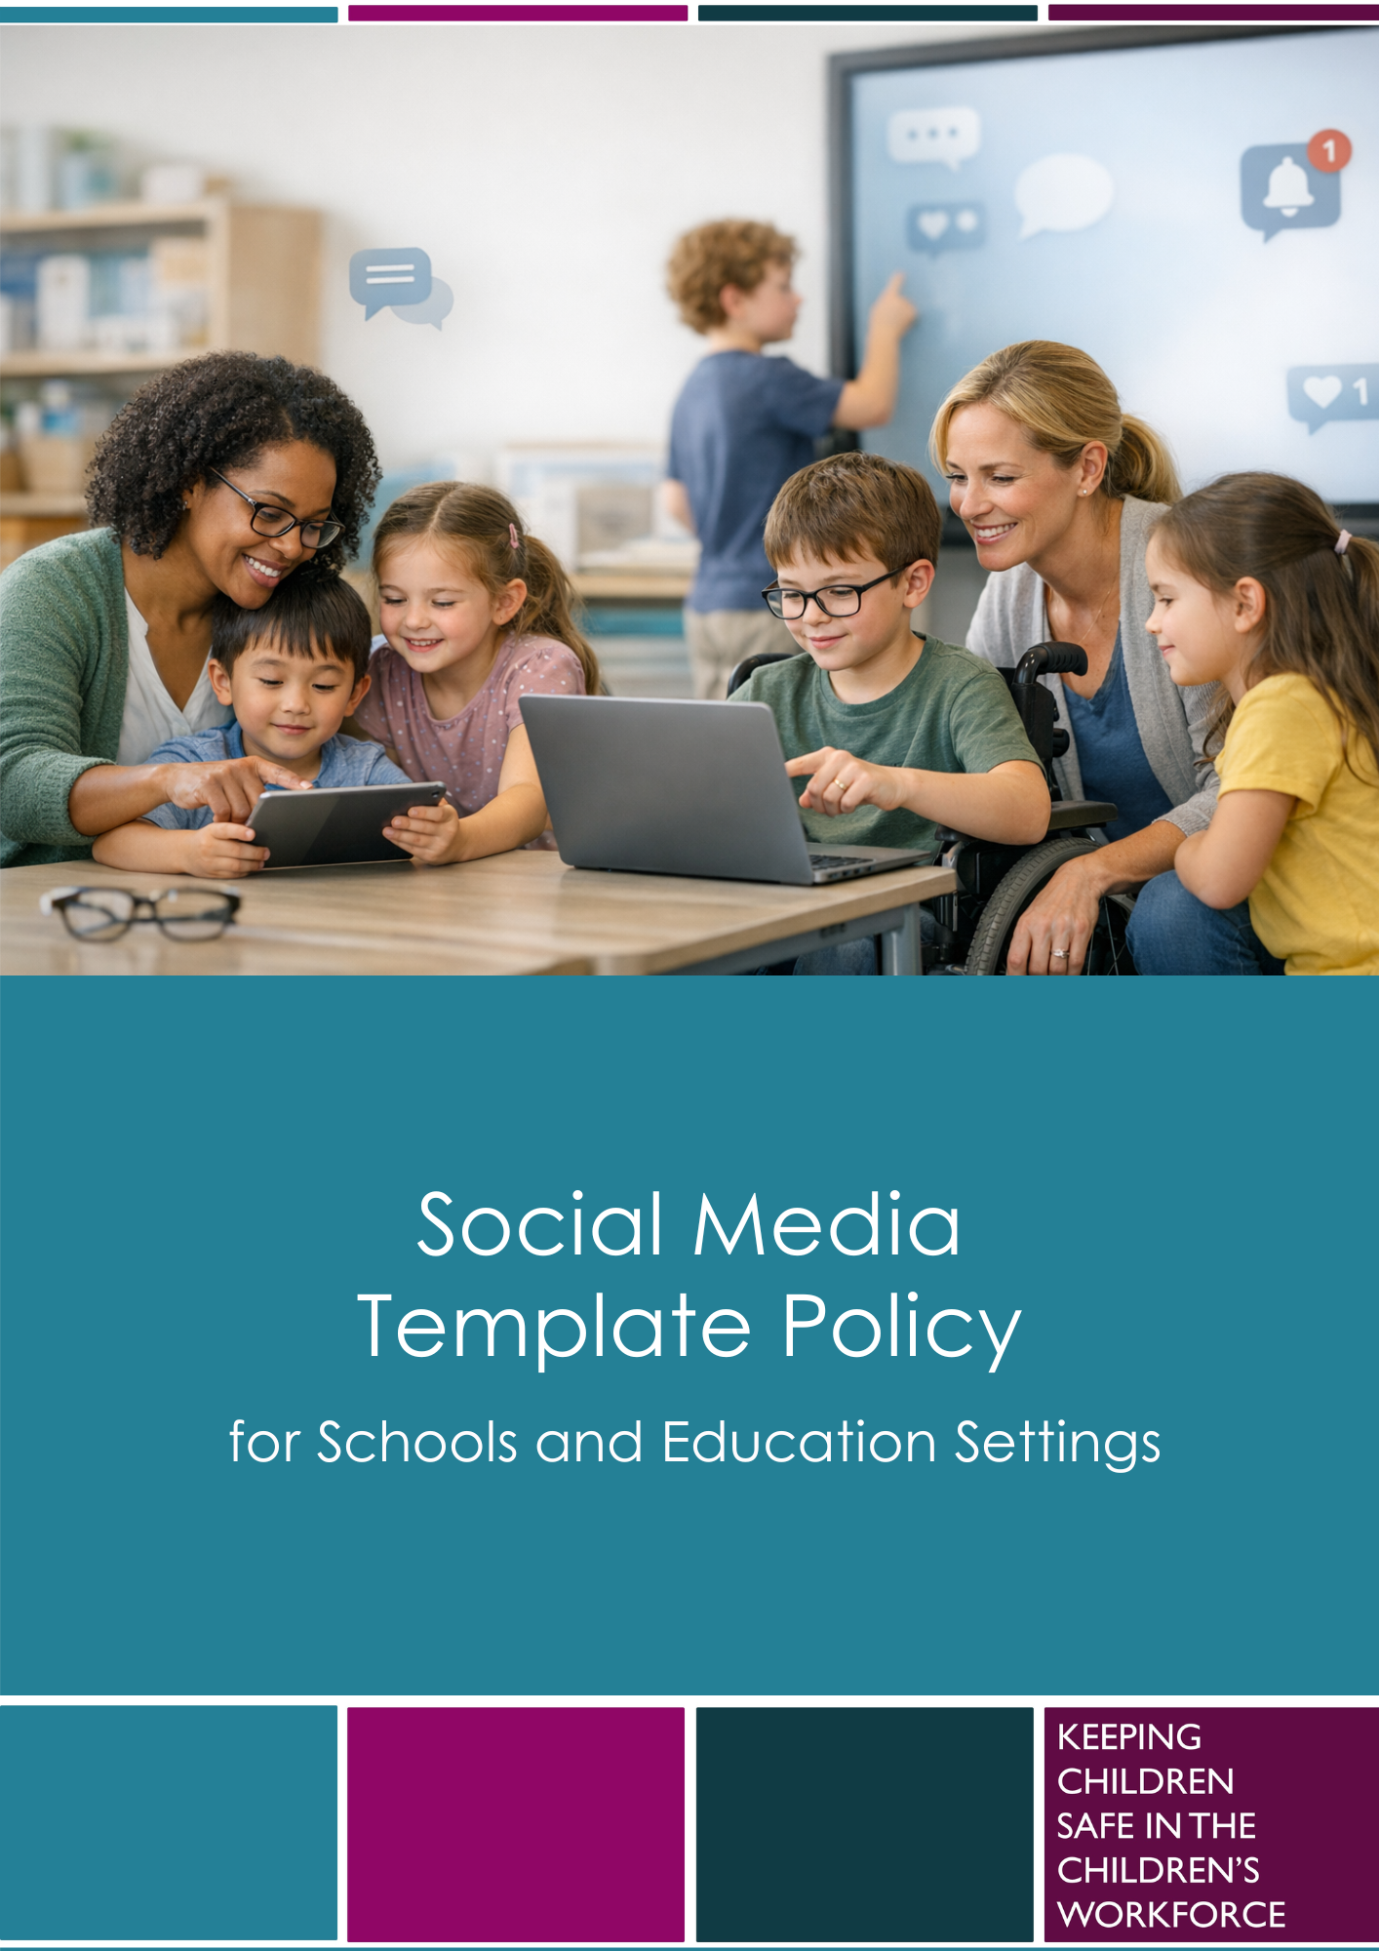

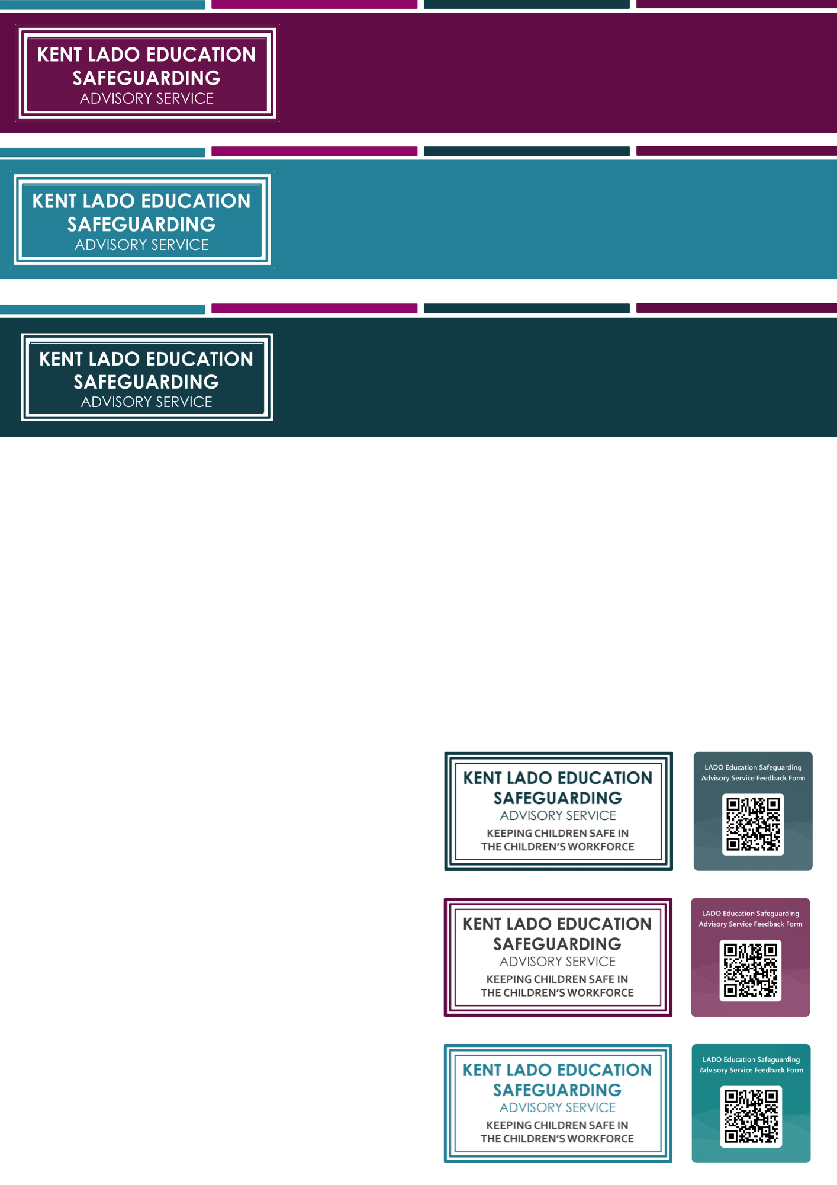

Social Media Policy Template
Guidance Notes

Safeguarding framework context
The template has been developed to help education settings meet the safeguarding requirements set out in ‘Keeping Children Safe in Education’ (KCSIE) and ‘Early Years Foundation Stage’ (EYFS). It also reflects the ‘Behaviour in Schools: Advice for headteachers and school staff’, ‘Mobile Phones in Schools’, DfE ‘Preventing and Tackling the Bullying and Harassment of School Staff’ and ‘Searching, screening and confiscation at school’.
Settings should be aware that some guidance may not apply to all age groups or contexts so leaders should review and adapt the content accordingly.
Recent and emerging national legislation is strengthening expectations around protecting children online. The UK Government has outlined new rules to increase safeguards for children in digital spaces, including restrictions on access to certain social media platforms and features, enhanced age assurance, and stronger protections against harmful content and contact. While these changes are being implemented over time, this policy reflects a broader safeguarding approach and recognises that the online environment is evolving rapidly. Settings should ensure this policy is kept under regular review to align with current guidance, legislation and emerging risks.

Why a social media policy is important
For the purposes of this policy, ‘social media’ refers to any online platform where users can create, share or interact with content. This includes social networking sites, messaging apps, blogs, forums, video and image sharing services and online gaming spaces.
Social media plays a significant role in the everyday lives of many children, families and staff. Clear expectations help protect the whole school or setting community, promote safe online behaviour and reduce risks linked to digital communication. A consistent approach also supports the orderly running of the setting and helps maintain positive relationships and professional standards.

Purpose and scope of the template
This template is suitable for schools, colleges, early years providers and other educational settings working with children. Leaders should ensure that any adaptations are appropriate for the age, abilities and needs of the children in their care.
This template provides a clear structure to help settings set out their approach to the safe and responsible use of social media. It forms part of a wider safeguarding portfolio and sits alongside existing child protection and/or online safety policies.
The headteacher, manager or registered person, together with the Designated Safeguarding Lead (DSL), hold overall responsibility for this policy. Other staff may contribute to ensure the policy is accurate, relevant and reflects local practice.
This policy does not cover technical elements such as network management, filtering or monitoring. These should be addressed in the setting’s wider child protection, online safety and IT infrastructure arrangements.
Related policies and guidance
This template should be implemented alongside other safeguarding, behaviour, data protection and online safety policies. Settings should ensure that expectations within this policy are consistent with their child protection policy, acceptable use of technology policies (AUPs), staff code of conduct, behaviour policy, complaints procedures, image/camera use policy and mobile phone and smart technology policy.
Schools should ensure that any references within this policy to pupil use of social media, mobile phones or smart technology are consistent with their mobile phone and smart devices policy. Schools are expected to follow the statutory DfE Mobile Phones in Schools guidance and should operate as mobile-phone-free environments by default unless a clear and justified exception applies.
When adapting this template, leaders may also wish to review additional guidance and resources relating to social media use, online conduct, harassment, complaints and image sharing. This may include:
- DfE Preventing and Tackling the Bullying and Harassment of School Staff guidance.
- DfE Harmful online challenges and online hoaxes guidance
- LESAS Responding to Complaints, Bullying and Harassment on Social Media guidance.
Settings should ensure that staff are aware of local procedures for reporting concerns relating to social media use, online harassment, complaints, safeguarding concerns and the misuse of images or recordings. Additional links and guidance can be found on KELSI.
Use of images on social media
Settings should ensure that any use of children’s images or recordings on official social media channels is considered as part of their wider safeguarding, data protection, image use and online safety arrangements. This policy should be read alongside the setting’s image/camera use policy and any local procedures for obtaining, recording, reviewing and withdrawing consent. Settings should also ensure that procedures are in place to respond to concerns involving images that are shared, copied, manipulated or misused through unofficial or personal social media accounts.
When adapting this template, leaders should consider current guidance on the safe publication of images online, including the potential for publicly available images to be copied, shared, altered, misused or manipulated using emerging technologies. Settings should take a safeguarding-first and proportionate approach by considering whether children need to be identifiable, avoiding unnecessary personal information, using safer image choices where appropriate, reviewing privacy and sharing settings, removing metadata before publication where possible, and ensuring staff understand local procedures.
Parents/carers and, where appropriate, children and young people should be given clear information about how images may be used, where they may be published, the potential risks of online sharing, and how consent can be withheld or withdrawn. Settings should refer to the UK Online Harms Early Warning Working Group guidance on protecting images from AI manipulation and abuse, and the LESAS Image Use Policy Guidance and Supporting Materials when reviewing local practice.

Using and adapting the templates
Settings are encouraged to involve staff, governors, parents/carers and, where appropriate, children in shaping their policy. This supports shared understanding and a consistent, community-wide approach.
Settings may use this resource as a standalone policy or integrate it into existing documents, such as behaviour, codes of conduct, acceptable use, child protection or online safety policies. Leaders should ensure staff, children and parents/carers know where to find the relevant information, especially regarding expectations and how to report concerns. Content must be adapted to reflect local procedures and named contacts. Any parts that are not relevant should be removed to ensure the final policy is clear and specific to the setting.

Where examples are included, they are designed to support leaders’ decision making. They should not be seen as requirements and do not replace professional judgements.
To support adaptation:
- [Blue font] indicates where the setting should insert local or contextual information
- Red italic font contains guidance for leaders and DSLs and should not appear in the final published policy.
- Yellow highlighting identifies new or updated content for 2026–27
We have used “safe adults” in this policy template, in line with NSPCC’s approach. Settings should adapt this wording so it is meaningful for their learners, taking account of age, ability, communication needs, lived experiences and local context. Alternative wording such as “trusted adult”, “grown-up”, “key adult”, “member of staff” or another locally understood phrase may be used, provided the message remains clear: children should know who they can speak to, how to seek help, and that adults will listen and respond appropriately to help keep them safe.

Disclaimer and copyright

This template was last reviewed in August 2026.
The Kent County Council LADO Education Safeguarding Advisory Service (LESAS) makes every effort to ensure that the information in our templates is accurate and up to date. However, safeguarding guidance, legislation and local procedures are subject to change. Schools and settings remain responsible for ensuring that their policies, procedures and practice reflect current statutory requirements and local safeguarding arrangements. If errors or omissions are brought to our attention, we will review and amend the document as soon as reasonably practicable.
The copyright of these materials is held by Kent County Council. Educational settings are granted permission to use, reproduce and adapt all or part of the materials for their own not-for-profit purposes, provided that Kent County Council's copyright is acknowledged and the materials are not sold, distributed commercially or presented as the intellectual property of another organisation.
Where settings adapt these materials for local use, they are responsible for ensuring that any amendments remain accurate, lawful and reflect current safeguarding guidance and local procedures.
Young Risers Pre-school

Social Media Policy
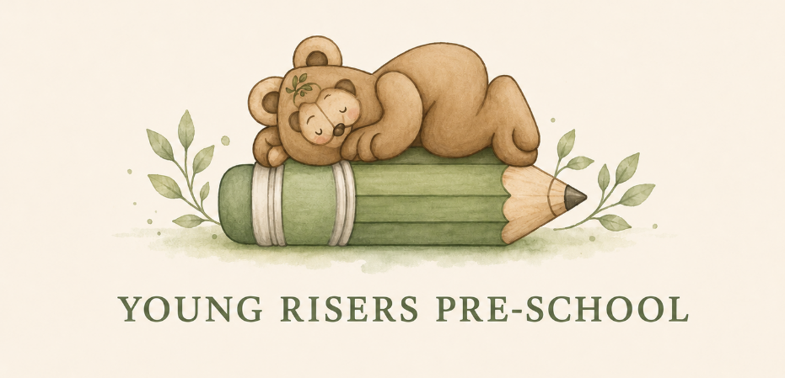

Key Details

Designated Safeguarding Lead (s): Beckie Francis & Ruby Eastwood

Date written/updated: September 2026
Date agreed and ratified by Governing Body : September 2026
Date of next review: September 2027

This policy will be reviewed at least annually. It will also be revised following any concerns and/or updates to national and local guidance or procedures.

Policy aims and scope
  - This policy has been written by Young Risers Pre-school, involving staff, children and parents/carers, building on the Kent County Council LADO Education Safeguarding Advisory Service Social Media policy template, with specialist advice and input as required.
  - It takes into account the Department for Education (DfE) guidance ‘Keeping Children Safe in Education’ (KCSIE), Early Years and Foundation Stage (EYFS) , ‘Working Together to Safeguard Children’(WTSC) and the local Kent Safeguarding Children Multi-agency Partnership (KSCMP) procedures.
  - The purpose of this policy is to safeguard and promote the welfare of all members of Young Risers Pre-school community when using social media.
    - Young Risers Pre-school recognises that online safety is an essential part of safeguarding and acknowledges its duty to ensure that all children and staff are protected from potential harm when using social media.
    - As outlined in our child protection policy, the Designated Safeguarding Lead (DSL), Beckie Francis has overall responsibility for online safety.
  - The policy applies to all use of social media; the term social media includes, but is not limited to, blogs, wikis, social networking sites, forums, bulletin boards, online gaming, apps, video/photo sharing sites, chatrooms and messenger apps or other online communication services.
- This policy applies to children, parents/carers and all staff, including the ], external contractors, visitors, volunteers and other individuals who work for, or provide services on behalf of the setting (collectively referred to as “staff” in this policy).

Links with other policies
- This policy links with several other policies, practices and action plans, including but not limited to:
- Acceptable Use Policies (AUP)
- Behaviour and discipline policy
- Child protection policy
- Staff [code of conduct/behaviour] policy
- Confidentiality policy
- Complaints policy
- Data security
- Mobile phone and smart devices

General social media expectations
- Young Risers Pre-school believes everyone should be treated with kindness, respect and dignity. Even though online spaces may differ in many ways, the same standards of behaviour are expected online as offline, and all members of our community are expected to engage in social media in a positive and responsible manner.
- All members of our community are advised not to post or share content that may be considered threatening, hurtful or defamatory to others on any social media service.
- We will monitor staff access to social media via our filtering and monitoring systems which are applied to all setting provided devices and systems; further information on how this is achieved is addressed in our child protection policy.
- Inappropriate or excessive use of social media during setting hours or whilst using setting devices may result in removal of internet access and/or disciplinary action.
- The use of social media or apps, for example as a formal remote learning platform or education tool will be robustly risk assessed by the DSL and manager prior to use with learners. Any use will take place in accordance with our existing policies.
- We expect members of our setting community to use social media responsibly and respectfully. Concerns about the setting, it’s staff or children should be raised through the setting published procedures wherever possible. Online conduct that is abusive, harassing, threatening, defamatory or otherwise inappropriate may be addressed in line with relevant policies and procedures and, where appropriate, reported to external agencies.
- Concerns regarding the online conduct of any member of Young Risers Pre-school community on social media will be taken seriously. This includes concerns relating to online complaints, harassment, intimidation or abuse directed towards staff, children or other members of the community. Concerns will be managed in accordance with the appropriate policies, including , allegations against staff, behaviour, staff behaviour/code of conduct, Acceptable Use Policies, and child protection.

Staff use of social media
- The use of social media during setting hours for personal use is not permitted for staff.
- Safe and professional online behaviour is outlined for all members of staff, including volunteers, as part of our staff code of conduct/behaviour policy and/or acceptable use of technology policy.
- The safe and responsible use of social media sites will be discussed with all members of staff as part of their induction. Staff play a key role in creating an environment where children feel safe to discuss their online experiences and report concerns. Advice will be provided and updated via staff training and additional guidance and resources will be shared with staff as required on a regular basis.
- Staff should be mindful of emerging technologies, including artificial intelligence tools and automated features, and must not use these in ways which could compromise confidentiality, professional standards or the safety and wellbeing of children.

Reputation

- All members of staff are advised that their online conduct on social media can have an impact on their role and reputation within the setting. Civil, legal or disciplinary action may be taken if staff are found to bring the profession or institution into disrepute, or if something is felt to have undermined confidence in their professional abilities.
- Members of staff are advised that content shared on social media may be widely viewed, copied or redistributed beyond their control. All members of staff are therefore advised to safeguard themselves and their privacy when using social media. This may include, but is not limited to:
- Setting appropriate privacy levels on their personal accounts/sites.
- Being aware of the implications of using location sharing services.
- Opting out of public listings on social networking sites.
- Logging out of accounts after use.
- Using strong passwords.
- Ensuring staff do not represent their personal views as being that of the setting.
- Members of staff are encouraged not to identify themselves as employees of Young Risers Pre-school on their personal social networking accounts; this is to prevent information being linked with the setting and to safeguard the privacy of staff members.
- All staff are expected to ensure that their social media use is compatible with their professional role and is in accordance with our policies and the wider professional reputation and legal frameworks. All members of staff are encouraged to carefully consider the information, including text and images, they share and post on social media.
- Information and content that staff members have access to as part of their employment, including photos and personal information about children and their family members or colleagues, will not be shared or discussed on social media sites.
- Members of staff will notify the leadership team and/or the Designated Safeguarding Lead immediately if they have concerns about content shared online which may impact their role, the setting, or the safety and wellbeing of children.

4.2 Communicating with children and their families

- Staff will not use any personal social media accounts to contact children or their family members. This is to maintain clear professional boundaries and safeguard both children and staff.
- All members of staff are advised not to communicate with or add any current or past children or their family members, as ‘friends’ on any personal social media accounts.
- Any communication from children and parents/carers received on personal social media accounts will be reported to the DSL (or deputy) and the manager.
- Any pre-existing relationships or situations, which mean staff cannot comply with this requirement, will be discussed with the DSL and the manager. Decisions made and advice provided in these situations will be formally recorded to safeguard children, members of staff and the setting.
- If ongoing contact with children is required once they have left the setting, members of staff will be expected to use existing alumni networks or use official setting-provided communication tools.

Official use of social media
- Young Risers Pre-school official social media channels are Young Risers pre-school (facebook) and we are young risers (Instagram).
- The official use of social media sites by Young Risers Pre-school only takes place with clear educational or community engagement objectives and with specific intended outcomes and once the use has been formally risk assessed and approved by the manager prior to use.
- Official social media sites are suitably protected and, where possible, run and linked from our website.
      - Official social media channels have been set up as distinct and dedicated accounts for official educational or engagement purposes only.
      - Staff use setting provided email addresses to register for and manage official social media channels.
      - Leadership staff have access to account information and login details for our social media channels, in case of emergency, such as staff absence.
- Official social media use will be conducted in line with existing policies, including but not limited to anti-bullying, image/camera use, data protection, confidentiality and child protection.
- All communication on official social media platforms by staff on behalf of the setting will be clear, transparent and open to scrutiny. Public communications on behalf of the setting will, where appropriate and possible, be read and agreed by at least one other colleague.
- Young Risers Pre-school will ensure that arrangements are in place to monitor and moderate comments, messages and interactions on official social media channels where these functions are enabled.
- Parents/carers and children will be informed of any official social media use, along with expectations for safe use and action taken to safeguard the community.
- Parents and carers will be informed of any official social media use with children; any official social media activity involving children will be moderated if possible and written parental consent will be obtained as required.
- We will ensure that any official social media use does not exclude members of the community who are unable or unwilling to use social media channels.
- Members of staff who follow and/or like our official social media channels will be advised to use dedicated professional accounts where possible, to avoid blurring professional boundaries.
- If members of staff are managing and/or participating in online social media activity as part of their capacity as an employee of the setting, they will:
  - Read and understand our Acceptable Use Policy.
  - Where they are running official accounts, sign our social media Acceptable Use Policy.
  - Be aware they are an ambassador for the setting.
  - Be professional, responsible, credible, fair and honest, and consider how the information being published could be perceived or shared.
  - Always act within the legal frameworks they would adhere to within the workplace, including libel, defamation, confidentiality, copyright, data protection and equalities laws.
  - Follow our image use policy at all times; for example, ensuring that appropriate consent has been given before sharing images.
  - Not disclose information, make commitments or engage in activities on behalf of the setting, unless they are authorised to do so.
  - Not engage with any private or direct messaging with current or past children or their family members.
  - Inform their line manager, the DSL (or deputy) and manager of any concerns, such as criticism, inappropriate content or contact from children.
- Any planned use of social media or online platforms with children for educational purposes will be risk assessed and appropriately supervised.
5.1 Use of images
- The use of photographs, videos and livestreamed content featuring children, staff or other members of the setting community will be undertaken in accordance with our image use policy, data protection requirements and safeguarding procedures.
- Before publishing images on social media, we will consider whether the content is necessary, proportionate and appropriate, taking account of safeguarding, privacy and potential online risks.
- We will not routinely publish unnecessary identifying information alongside images, such as full names, personal details, locations, routines or information which could increase the risk of an individual being identified or targeted.
- We recognise that images shared online may be copied, redistributed, manipulated or misused, including through the use of artificial intelligence and other emerging technologies. We will take reasonable steps to minimise risk when selecting, storing and sharing imagery.
- Where images or recordings are shared via official social media channels, this will take place in line with the setting’s consent processes, image use procedures and data protection requirements.

Children use of social media
- Young Risers Pre-school recognises that the use of social media by children presents opportunities for learning, entertainment and participation. However, it can also bring safeguarding risks, including exposure to harmful content, contact from unknown individuals, abuse, and pressures linked to online interactions.
- The use of social media during setting hours for personal purposes is not permitted for children in line with safeguarding, behaviour and curriculum considerations.
- While much online behaviour takes place off-site, outside of the setting day, we will work in partnership with parents/carers, who play an essential role in ensuring children’s safe use of technology.
- We take a contextual safeguarding approach to online behaviour and recognise that children’s experiences outside the setting, including online, can have a significant impact on their safety and wellbeing. Where behaviour online poses a risk of harm to a child, impacts the safety or wellbeing of members of the community, or could affect the running or reputation of the setting, we will respond in line with our behaviour and child protection policies.
- We recognise that age restrictions for social media and online services vary depending on the platform and are subject to change as legislation and regulatory expectations evolve. We will not create accounts for children who do not meet the required age thresholds set out by the relevant service provider and current legal or regulatory requirements.
- We recognise that, regardless of age restrictions or setting expectations, many children and young people will continue to access or be exposed to social media and online content. We are committed to ensuring that all children feel safe, supported and able to talk to safe adults about their online experiences, including any concerns, worries or incidents, without fear of blame or automatic sanction.
- Young Risers Pre-school will empower our children to acquire the knowledge and skills needed to use social media and online services (including emerging features and technologies) in a safe, considered and respectful way. Safe and appropriate use of social media will be taught to children as part of an embedded and progressive safeguarding education approach using age-appropriate sites and resources. Further information is contained within our child protection and relevant specific curriculum policies.
- Children will be advised:
- to consider the benefits and risks of sharing personal details or information on social media sites which could identify them and/or their location.
- to only approve and invite known friends on social media sites and to deny access to others, for example by making profiles private.
- not to meet any online friends without a parent/carer or other appropriate adults’ permission, and to only do so when a safe adult is present.
- to use safe passwords.
- to use social media sites which are appropriate for their age and abilities.
- how to block and report unwanted communications.
- how to report concerns on social media, both within the setting and externally.
- how to report concerns within the setting, including speaking to a safe adult or a Designated Safeguarding Lead.
- Any concerns regarding children use of social media will be dealt with in accordance with appropriate existing policies, including anti-bullying, child protection and behaviour.
- The DSL (or deputy) will respond to social media concerns involving safeguarding or child protection risks in line with our child protection policy.
- Sanctions and/or pastoral/welfare support will be implemented and offered to children as appropriate, in line with our child protection and behaviour policy. Civil or legal action may be taken if necessary.
- Concerns regarding children use of social media will be shared with parents/carers as appropriate, particularly where there are safeguarding or age-related concerns.

Responding to policy breaches
- Young Risers Pre-school recognises that online abuse, bullying, harassment or intimidation of staff is unacceptable. Concerns involving harmful, abusive or threatening online behaviour towards staff by pupils, parents/carers or members of the wider community will be taken seriously , recorded as appropriate, and responded to in line with relevant policies and procedures, including behaviour, complaints, staff conduct, safeguarding and, where appropriate, police reporting processes. Young Risers Pre-school expects all communication, including communication via social media, to be respectful and constructive.
- Concerns relating to photographs, videos or other images shared via social media, including inappropriate sharing, unauthorised publication, misuse, manipulation or the use of artificial intelligence to create, alter or generate imagery, will be taken seriously. The setting will respond in line with safeguarding, child protection, data protection and behaviour procedures. This may include removing content where possible, recording concerns, supporting affected individuals and seeking advice from, or reporting concerns to, external agencies where appropriate.
  - All members of the community are informed of the need to report policy breaches or concerns in line with existing setting policies and procedures.
  - After any investigations are completed, leadership staff will debrief, identify lessons learnt and implement any policy or curriculum changes, as required.
  - We require staff, parents/carers and children to work in partnership with us to resolve issues.
  - All members of the community will respect confidentiality and the need to follow the official procedures for reporting concerns.
  - Children, parents and staff will be informed of our complaints procedure and staff will be made aware of the whistleblowing procedure.
  - If we are unsure how to proceed with an incident or concern, the DSL (or a deputy) or manager will seek advice from the local authority or other agencies, as appropriate, in accordance with our child protection policy.

Policy monitoring and review
- Technology evolves and changes rapidly. Young Risers Pre-school will review this policy at least annually. The policy will be revised following any national or local policy updates, any local concerns and/or any changes to our technical infrastructure.
- We will regularly monitor internet use taking place via our provided devices and systems and evaluate online safety mechanisms to ensure that this policy is consistently applied. Any issues identified will be incorporated into our action planning.
- All members of the community will be made aware of how the setting will monitor policy compliance

