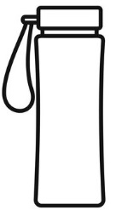  Water – is the best choice  Milk – Use semi-skimmed (for children aged two and over  Avoid – fruit juice (even diluted fruit juice)  Avoid – squash, fizzy drinks and flavoured water even if labelled sugar free, no added sugar or reduced sugar these can contribute to tooth decay and have little nutritional value  A drink  Desserts, cakes, biscuits and crisps: these foods are high in saturated fat, sugar and salt – too much of these food can be harmful to health.  Try to make desserts, puddings and cakes with fruit or milk, such as yoghurt and fruit, or rice pudding.  Limit confectionery such as chocolate, sweets or cereal bars to help protect your child’s teeth.  Avoid salty snacks such as crisps. Replace with breadsticks. |  | Practical Tips for Healthy, safe and tasty packed lunches  Choosing Foods  - Vary lunchbox contents for a good balance of nutrients.  - Seasonal fruits and vegetables add colour, texture and are often cheaper and tastier.  - Read food labels, look out for colour coded nutrition information on the front of packets, remember the more green’s on the label the healthier the choice.  Preparing the packed lunch  - Include your child in shopping, choosing and preparing what goes in their lunchbox, giving them choices within the food groups.  - Wash fruit and vegetables, and remove any stones.  - Keep it fresh, rinsing sliced apple in dilute lemon juice as it will stop the slices from turning brown.  - Think sustainably, use containers and cutlery that can be washed and used again.  - Label your child’s lunch box/bag  - In warmer weather put an ice pack in the lunch box/bag to keep cool.  - Ensure your child has their own drinks bottle with their name on. |  | 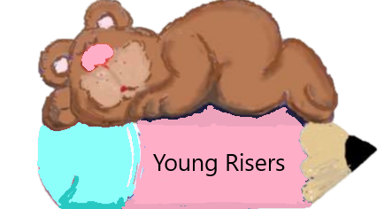  Healthy Packed Lunches for Early Years  A practical guide for parents and carers  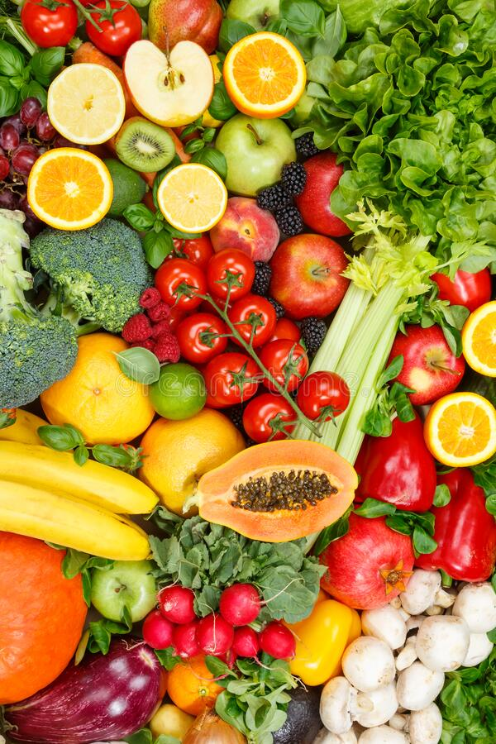
A healthy lunch every day will give your child the energy and nutrients they need to grow and develop and learn. Young Risers encourages children to eat healthy and they need your support.  The key to a balanced, nutritious diet is variety. This leaflet provides you with some ideas of what to include to ensure that your children’s packed lunch is healthy, balanced and nutritious.  The Food Groups  Potatoes, bread, rice, pasta and other starchy carbohydrates  These foods provide carbohydrates to give your child energy for the afternoon.  Fruit and Vegetables  These foods provide vitamins and minerals to help protect against illness.  Beans, pulse, fish, eggs, meat and other proteins  These foods provide protein, iron and zinc to help your child grow.  Dairy and alternatives  These foods are good source of calcium, for strong bones and teeth  Foods and drinks high in saturated fat, sugar (and/or salt).  Try to limit these types of food and drink. Too much salt and saturated fat can increase the risk of some illnesses in later life while too much sugar can damage children’s teeth. |  | A portion of milk or dairy foods  Yoghurt of fromage frais, cheese in sandwiches or wraps.  A portion of Starchy food  White or wholegrain bread, rolls, pitta bread or wraps, plain naan bread, bagels, cooked pasta, rice, noodles, couscous or potato as a salad.  A portion of beans, pulses, fish, eggs, meat and other proteins  Sliced meat, chicken, fish, sliced egg in sandwiches, rolls or wraps, meat alternatives such as tofu or pulses like kidney beans and chickpeas in salads.  At least one portion of fruit and/or vegetable  Fresh, frozen, canned or dried, these can all be counted towards 5-A-Day  Vegetables – Carrot, cucumber, tomatoes, pepper, celery, carrot or sweetcorn.  Fruit – Apple, melon, plums, grapes, strawberries, kiwi, satsumas, pineapple or dried fruit  Healthy packed lunch ideas  Examples of a Healthy Lunch box  